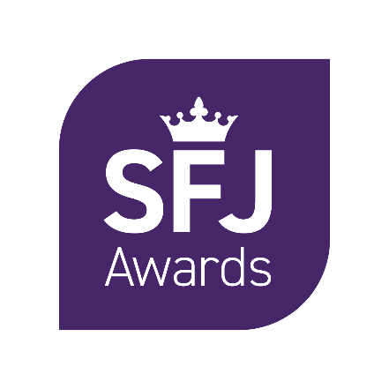

Malpractice and Maladministration Reporting Form

Contents

Contents 2

1. Introduction 3

2. Centre details 3

3. Description of Case 4

1. Introduction

**1.1 Malpractice and Maladministration Policy**

We advise that both Learners and Centres read SFJ Awards’ Malpractice and Maladministration Policy to ensure you are familiar with the procedures and protocols that have been put in place. You can download a full copy of our policy at [www.sfjawards.com](http://www.sfjawards.com)

**1.2 Completion of this form**

Please take note of the following points:

* We take all cases of suspected or actual malpractice/maladministration very seriously
* Please provide as much information as possible by completing all sections of the form as fully as possible and attach copies of supporting evidence and investigation reports
* If required, please use additional sheets and provide any supporting evidence
* Please email the completed form to [qateam@sfjawards.com](mailto:qateam@sfjawards.com)

1. Centre details

|  |  |
| --- | --- |
| Centre name |  |
| Address / site |  |
| Main Centre Contact Name |  |
| Position |  |
| Telephone Number |  |
| Email Address |  |
| Date submitted to SFJ Awards |  |

1. Description of Case

|  |  |  |  |  |
| --- | --- | --- | --- | --- |
| Learner Name and Odyssey ID Number | Qualification | Investigating Officer name / Position | Date of Incident | Date centre investigation concluded |
|  |  |  |  |  |
|  | | | | |
| Describe the nature of the suspected malpractice/ maladministration, including details as to how it was discovered by whom and when, and how it occurred. |  | | | |
| Describe the steps the centre has taken to gather information relating to this matter. |  | | | |
| Is this an isolated case? |  | | | |
| Describe how and when learners are made aware of the examination or assessment regulations. |  | | | |
| Could learners have been unfairly advantaged or disadvantaged by the suspected malpractice/ maladministration? If so, please give details |  | | | |
| Please provide details of the investigation conclusion and outcome for learners/staff |  | | | |
| What actions will be taken to prevent a recurrence? |  | | | |

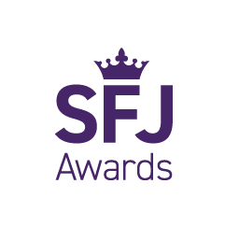

**SFJ Awards**  
Consult House  
4 Hayland Street  
Sheffield S9 1BY  
Tel: 0114 284 1970

sfjawards.com

