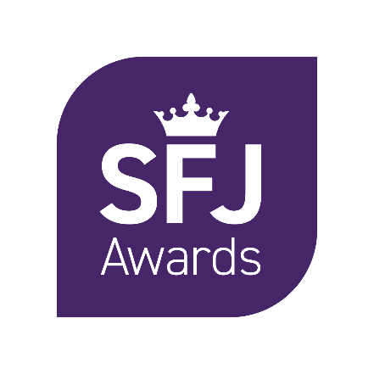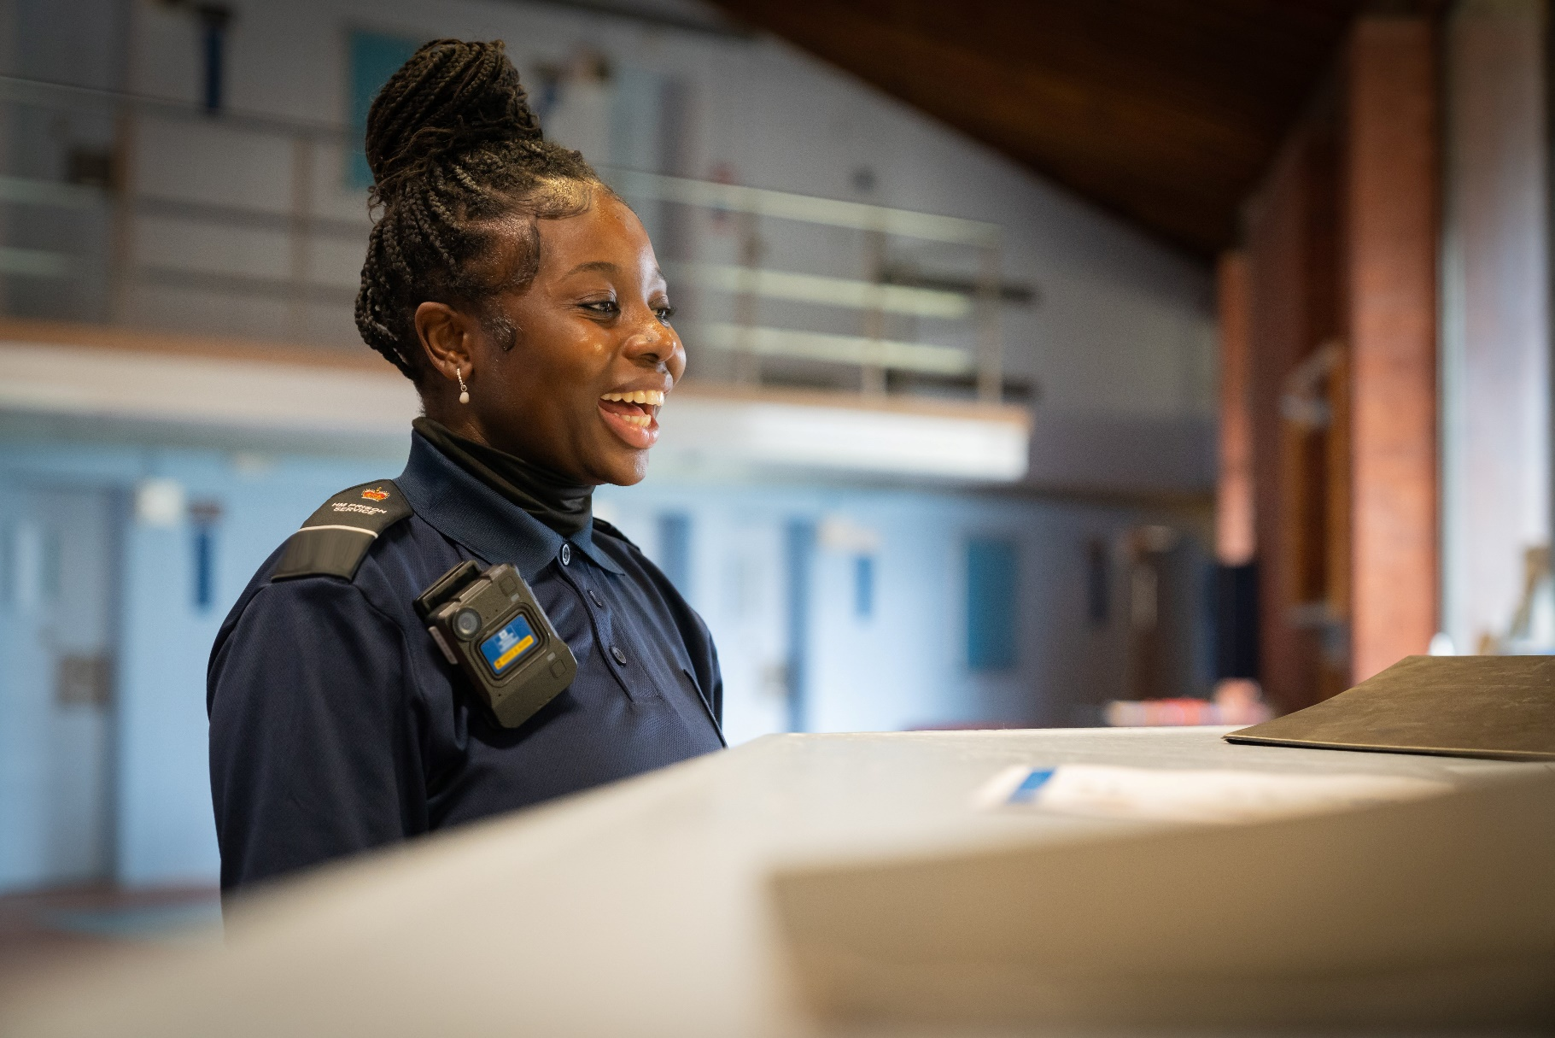

Malpractice and Maladministration Reporting Form

Contents

Contents 2

1. Introduction 3

2. Details 4

3. Description of Case 5

4. Personal Details 6

1. Introduction

**1.1 Malpractice and Maladministration Policy**

We advise that both Learners and Centres read SFJ Awards’ Malpractice and Maladministration Policy to ensure you are familiar with the procedures and protocols that have been put in place. You can download a full copy of our policy at [www.sfjawards.com](http://www.sfjawards.com) or alternatively request a hard copy by contacting us as detailed below.

**1.2 Completion of this form**

Please take note of the following points:

* We take all cases of suspected or actual malpractice/maladministration very seriously
* Please provide as much information as possible by completing all sections of the form as fully as possible and attach copies of supporting evidence and investigation reports
* If required, please use additional sheets and provide any supporting evidence

**1.3 Reviewing the Case**

* Once we have received the form we will write to you confirming receipt
* When the final decision is made we will inform you of the outcome within ten working days
* At SFJ Awards we aim to have the whole review completed within a 30 day timeframe, however this may be longer depending on the nature of the case
* We will ensure that the specified contact/s in this form are kept updated

**1.4 Contact Details**

**Address**:

SFJ Awards

Consult House  
4 Hayland Street  
Sheffield  
S9 1BY

Email: [qateam@sfjawards.com](mailto:qateam@sfjawards.com)

Telephone: 0114 284 1970

**General Enquiries:**

Email: [info@sfjawards.com](mailto:info@sfjawards.com)

Telephone: 0114 284 1970

[www.sfjawards.com](http://www.sfjawards.com)

1. Details

|  |  |
| --- | --- |
| Centre Name |  |
| Address |  |
| Main Centre Contact Name |  |
| Position |  |
| Telephone Number |  |

|  |  |  |
| --- | --- | --- |
|  | | |
|  | Name of Learners/Staff Applicable | Possible Sources of Evidence |
| 1 |  |  |
| 2 |  |  |
| 3 |  |  |
| 4 |  |  |
| 5 |  |  |
| 6 |  |  |

Please contact the Centre Administrator to request a Learner’s Registration Number, if appropriate.

|  |  |
| --- | --- |
| Qualification Title |  |
| Date of Incident |  |

1. Description of Case

|  |
| --- |
| Please detail in full the suspected or actual malpractice or maladministration below. Please include Odyssey learner registration numbers if applicable.  Please indicate below the supporting evidence submitted with this report. All relevant information and materials must be submitted at this time, e.g. centre investigation report and outcomes.  Please use additional sheets where required and attach additional evidence. |
|  |

1. Personal Details

|  |  |
| --- | --- |
| Full Name |  |
| Position |  |
| Email Address |  |
| Telephone Number |  |
| Date |  |
| Signed |  |

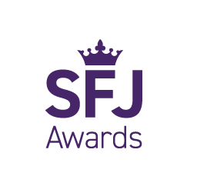

**SFJ Awards**  
Consult House  
4 Hayland Street  
Sheffield S9 1BY  
Tel: 0114 284 1970

sfjawards.com

