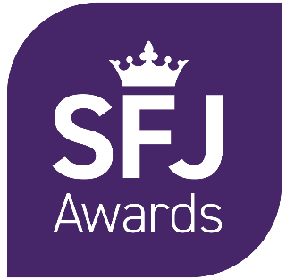

Malpractice and Maladministration Reporting Form

Contents
Contents 2
1. Introduction 3
2. Centre details 3
3. Description of Case 4

- Introduction
1.1 Malpractice and Maladministration Policy
We advise that both Learners and Centres read SFJ Awards’ Malpractice and Maladministration Policy to ensure you are familiar with the procedures and protocols that have been put in place. You can download a full copy of our policy at www.sfjawards.com

1.2 Completion of this form
Please take note of the following points:
- We take all cases of suspected or actual malpractice/maladministration very seriously
- Please provide as much information as possible by completing all sections of the form as fully as possible and attach copies of supporting evidence and investigation reports
- If required, please use additional sheets and provide any supporting evidence
- Please email the completed form to qateam@sfjawards.com

- Centre details
Centre name
Address / site

Main Centre Contact Name
Position
Telephone Number
Email Address
Date submitted to SFJ Awards

- Description of Case
Learner Name and Odyssey ID Number | Qualification | Investigating Officer name / Position | Date of Incident | Date centre investigation concluded
Describe the nature of the suspected malpractice/ maladministration, including details as to how it was discovered by whom and when, and how it occurred.
Describe the steps the centre has taken to gather information relating to this matter.
Is this an isolated case?
Describe how and when learners are made aware of the examination or assessment regulations.

Could learners have been unfairly advantaged or disadvantaged by the suspected malpractice/ maladministration? If so, please give details
Please provide details of the investigation conclusion and outcome for learners/staff
What actions will be taken to prevent a recurrence?

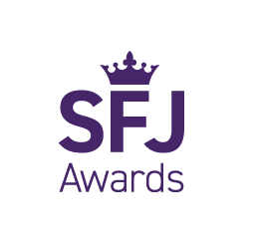


SFJ Awards
Consult House
4 Hayland Street
Sheffield S9 1BY
Tel: 0114 284 1970
sfjawards.com

