
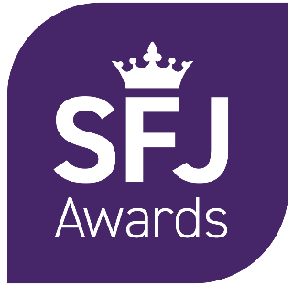

Level 5 Diploma in Professional Policing Practice
Qualification Approval Form

Centre Details:
Centre Name
SFJ Awards Centre Number
(if known)
Centre Contact | First Name
Centre Contact | Surname
Centre Contact | Email address
Centre Contact | Contact Number

Declaration
By submitting this form, the signatory confirms and agrees that:
- They are authorised to submit this form on behalf of the centre
- They have read the requirements stated in SFJ Awards Centre Handbook and the appropriate Qualification Handbook(s)
- The information provided in this approval application is complete and accurate
- If this application is accepted by SFJ Awards, it will be added as an addition to the centre agreement between the SFJ Awards and the centre
- They provide consent for SFJ Awards to review their College of Policing-approved QSA report, a copy of which is attached to this application form.
Head of Centre Name
Date

Staff Details:
Please enter the details of staff who will be involved in the assessing or internal quality assurance (IQA) of the SFJ Awards Level 5 Diploma in Professional Policing Practice. To reduce administrative burden where possible, if the assessor or IQA has previously worked on qualifications such as the Level 3 Diploma in Policing or other entry routes such as DHEP, and have already been approved by SFJ Awards, we do not require their CVs or certificates
Assessor(s) |  | IQA(s) |  | Individual has assessed or IQA’d for L3 Dip. in Policing or other entry routes such as DHEP  Y/N
First Name | Last Name | First Name | Last Name

SFJ Awards Use Only:
Reviewed By:
Role:
(EQA / SFJ Awards QA Officer)
Date Reviewed:
Comments:
Outcome: |  | Recommended – meets criteria  Not at this time (Actions to be addressed)  Declined (please add comment above)
A =  Action  R =  Recommendation | Action Required / Recommendation |  | By Whom | By When

